**AWS Cross Account Access**

We need two AWS account for cross account access

Let assume we have Account A of our colleague , we want to access all the resources of this account.

We have our own Account B and we will login using IAM user of B, to see the resources of A

Step 1) Create **IAM Role** in **Account A.**

* Copy the Account ID of B e.g. 123456789

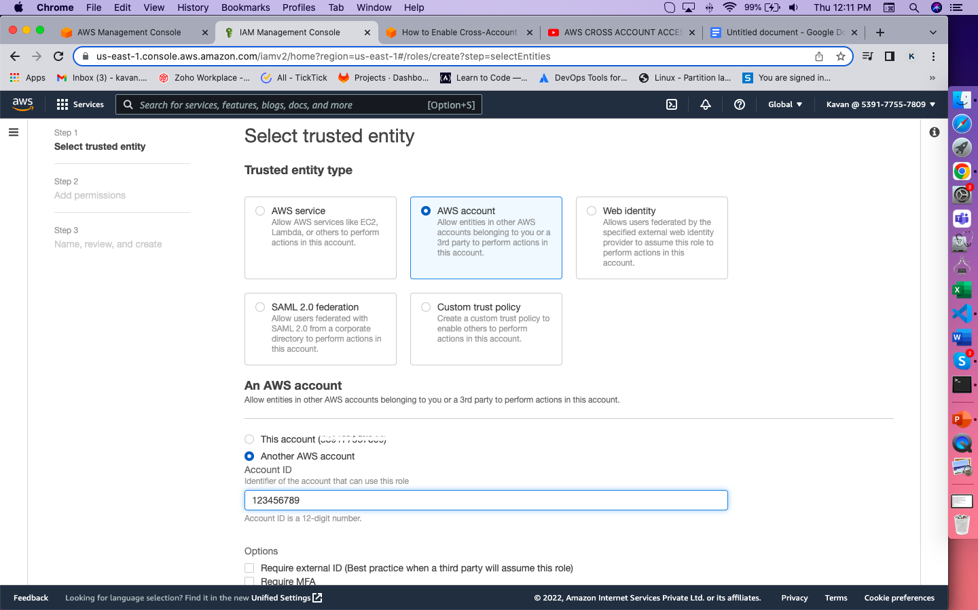

* Click Next
* Select the PowerUserAccess Permission

This lets users from the B account work with all services in the A account *except* IAM. For example, they won’t be able to change the permissions for the role they’re assuming, and they won’t be able to create new users or roles.

* Click Next
* Give name to the Role e.g. “CrossAccountUser”
* Click Create

Step 2) Create a **IAM User** in **Account B**

Give User permission to assume the role created in Account A

{

"Version": "2012-10-17",

"Statement": [{

"Effect": "Allow",

"Action": ["sts:AssumeRole"],

"Resource": "arn:aws:iam::*Prod-account-ID*:role/CrossAccountSignin"

}]

}

Replace the ARN of the role you created in Account A in the “Resource” value pair.

Step 3) Login with the IAM User of Account B

* Click on **Swtich Role**
* Provide the Account ID number of account A
* Provide the IAM Role Name from account A, in our case it is “CrossAccountUser”

